Contents

Background 2

Dataset: 2

Model: 2

Inference: 5

How to run: 7

Background:

The purpose of this document is to explain the methodology behind object detection and tracking sample project for Sketric Solutions job application. The task included training a model on a dataset to detect objects in a video and then creating an algorithm for tracking that object. The model that I’ve trained detects knife objects in a video and tracks them as they move across the frames.

# Dataset:

Instead of using a large dataset, I opted for a custom small dataset that I created myself to save computation resources. I used labelImg, a python application, to label the dataset. I captured 40 images holding a knife at varying orientations and angles. Each of these images are then labelled separately. Since the model I’ll be using is yolov8, I needed to label the dataset with accordance to the yolo parameters. A default template for this is “classID x1 x2 x3 x4” where x1-4 are the limits of bounding box around the object of interest. Label files are stored in the label folder while the original images are stored in images folder. After that a yaml file needs to be created that defines the path of images for training and validation along with the number of classes and the names of those classes. That yaml file is what yolo functional API uses to load dataset.

# Model:

In the folder you’ll find the objectDetectionYolov8Code.ipynb file which was used for training. Due to lack of computational resources I used google colab for this, and then downloaded the trained model file to run inference locally. In the colab file, i first installed ultralytics which downloads the necessary libraries for us. I load the yolov8 model using YOLO’s functional API. At this point I should mention that I created a model from scratch using tensorflow, however, it lacked the necessary depth in architecture and fine tuning it would’ve taken too much time, therefore, I confined my efforts to using a SOA architecture model. There’s two ways of training yolo, you can either use only the architecture without any weights or you can use weights and then have your own training on top of it. First I utilized the architecture only approach and the results were not that impressive. I get an mAP50 of only 0.149 for the validation dataset. The results down below show that box loss which is the regression part of the object detection is going down, however, it’s still unusable for us. And so is the classification loss which performs the object labelling in the object detection algorithm.

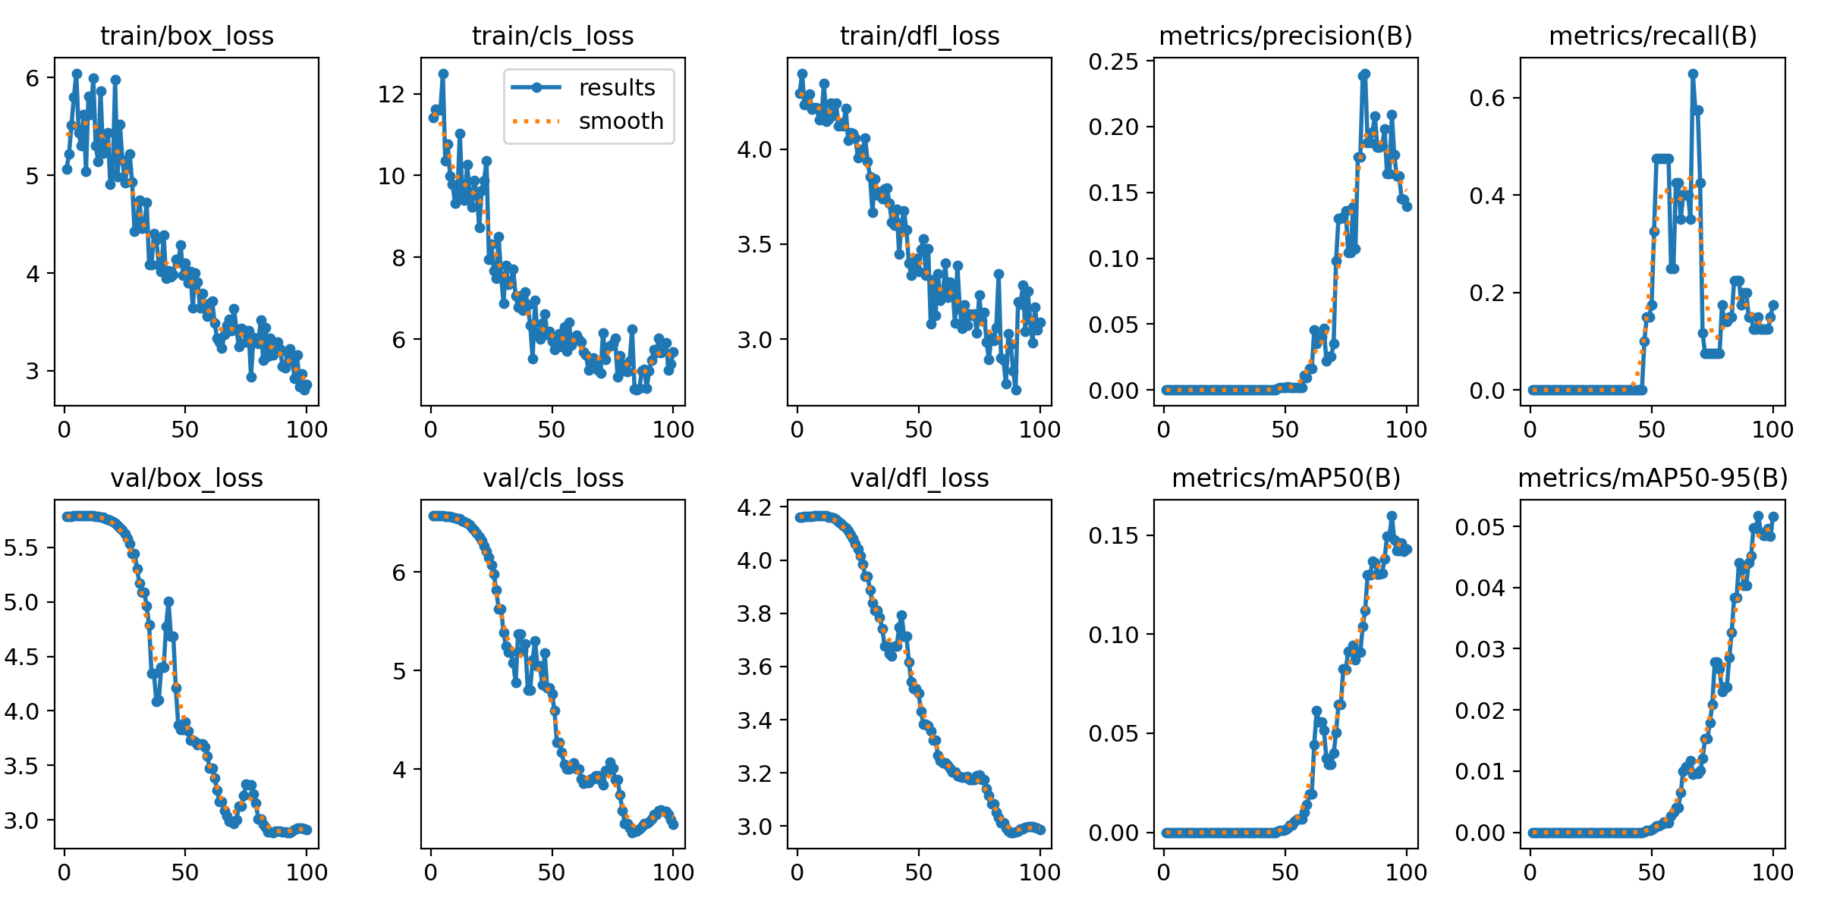

Here are the results for validation dataset prediction. Not a single image is correctly labelled.

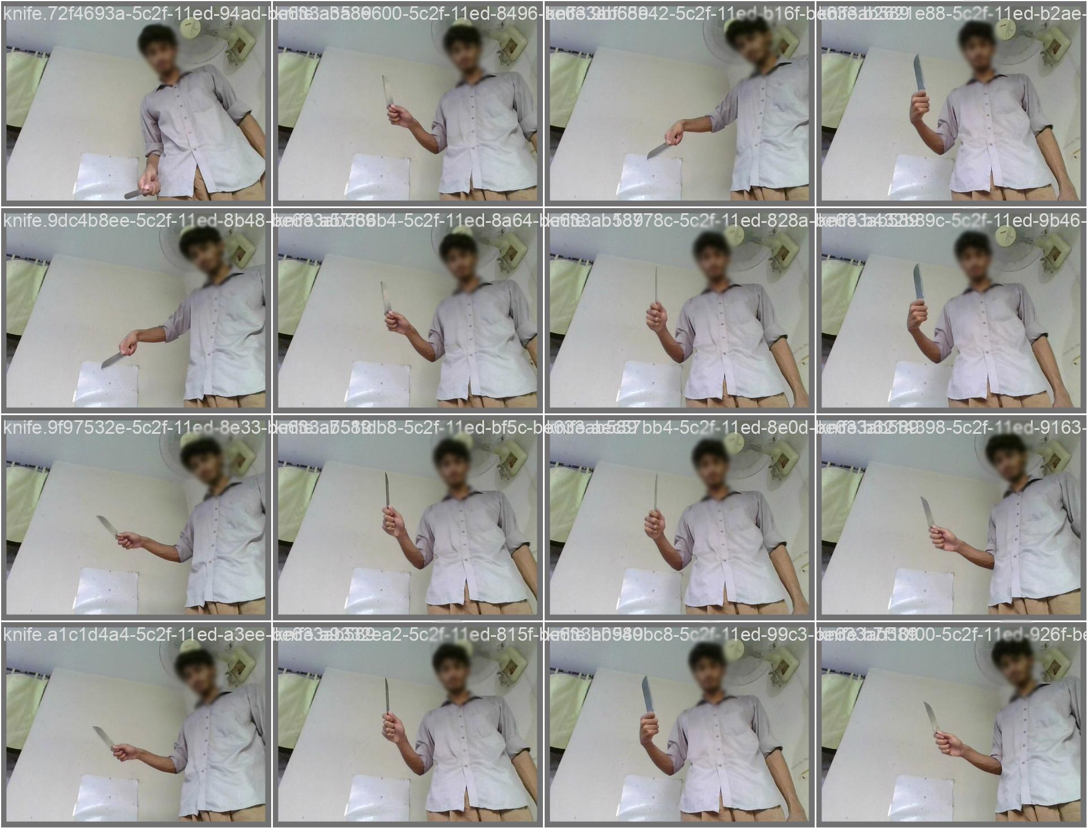

I then shifted my approach to use pre-trained model weights for my training. Running the training for 100 epochs I got following results.

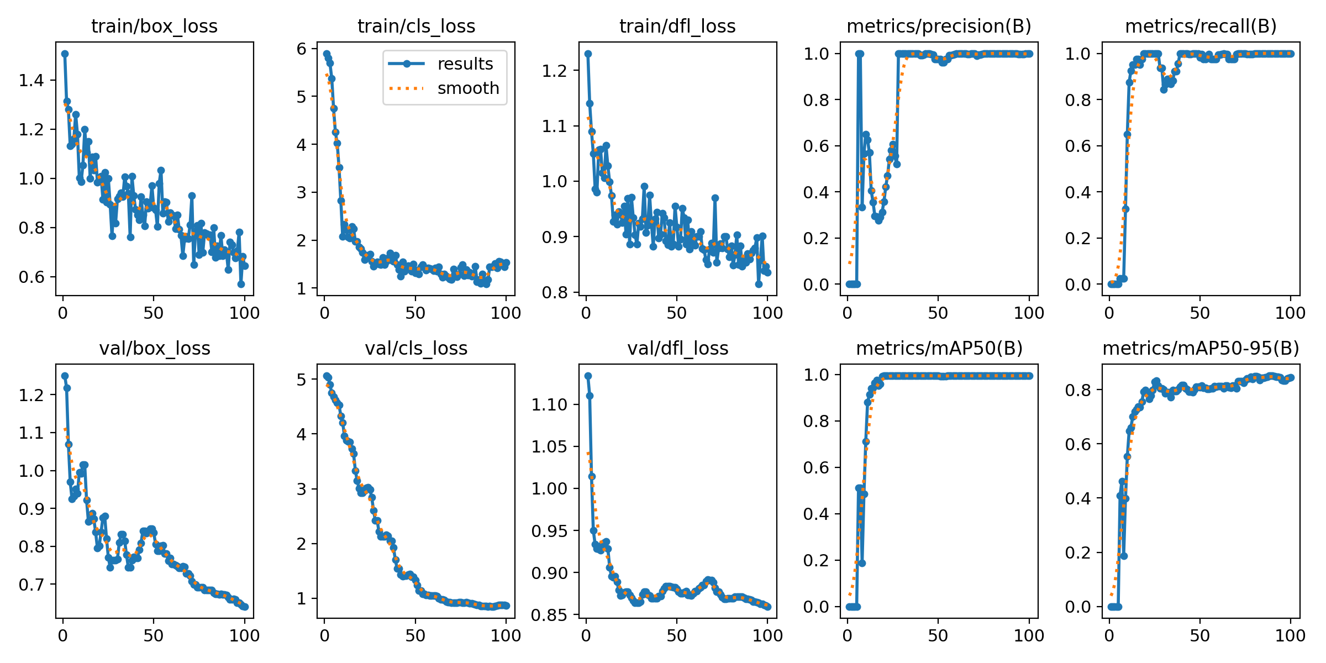

The results are much better with loss approaching zero and mAP50 approaching 1. I would consider this model over-trained, however, given the small dataset and time restriction, over-trained in this case is better than being undertrained. Here are the results for the validation dataset prediction.

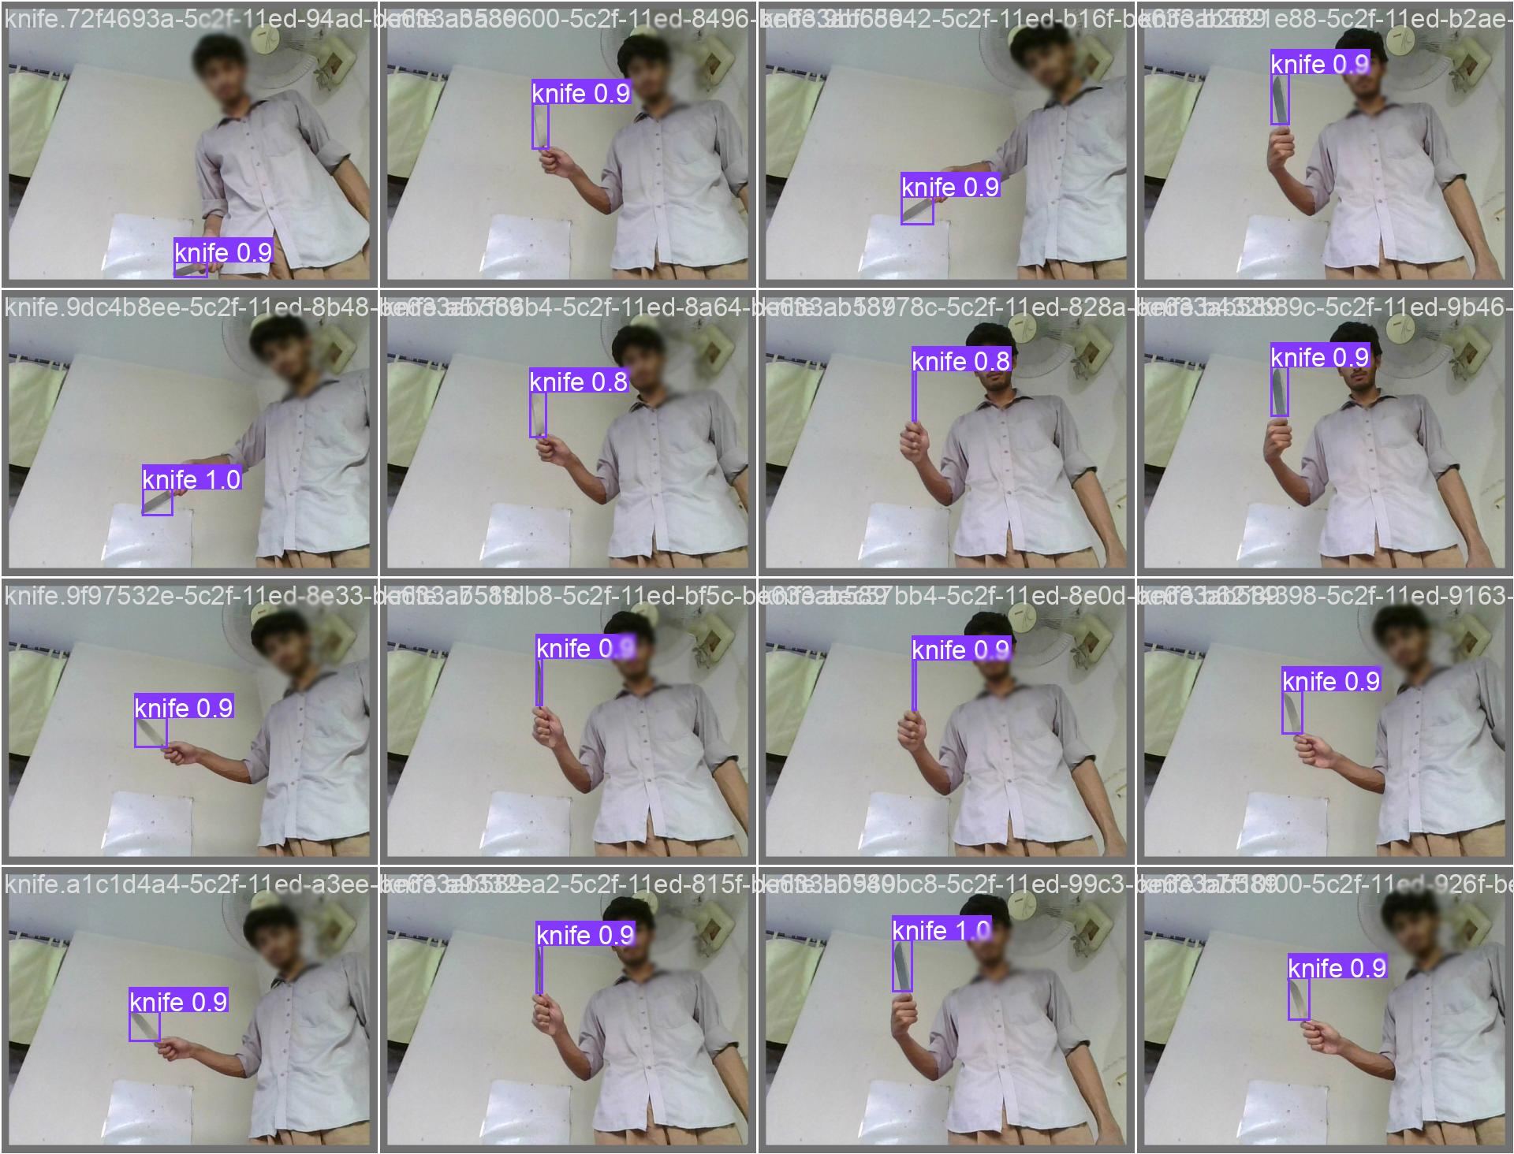

All the images are correctly labelled during prediction. This model can be further improved by using a larger dataset.

# Inference:

The next step is inference on live video and object tracking. I’ve created a simple application using tkinter library that allowed me to test the inference. This basic application offers a very simple interface. You can run inference on a video available in the folder or you can run inference from the webcam feed. A stop button stops the inference from one of the feed. It is necessary to stop one source to start another.

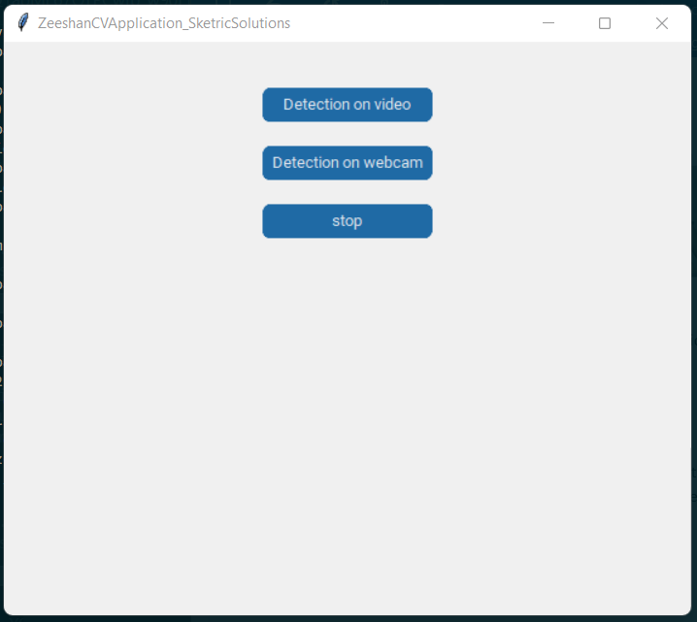

For the object tracking algorithm, time restriction was quite a hurdle therefore I could only manage a barebones tracking algorithm that takes the center of the regression frame and stores it in a list. The program then draws the path of the predicted object. There are several drawbacks to this as multiple objects would cause problem, also object hidden for a several portion of the video would cause problems. A much better implementation would be something like deepsort algorithm that is able to overcome all these issues.

I get laggy video when running inference on my CPU. That is because each frame takes a compute time which causes lag. A quick fix was that I skipped every other frame during inference which gave slightly better fps. A better fix would be either buffer few frames in advance or use a GPU that can handle computations a lot better.

Below is a still frame from the application running inference on video

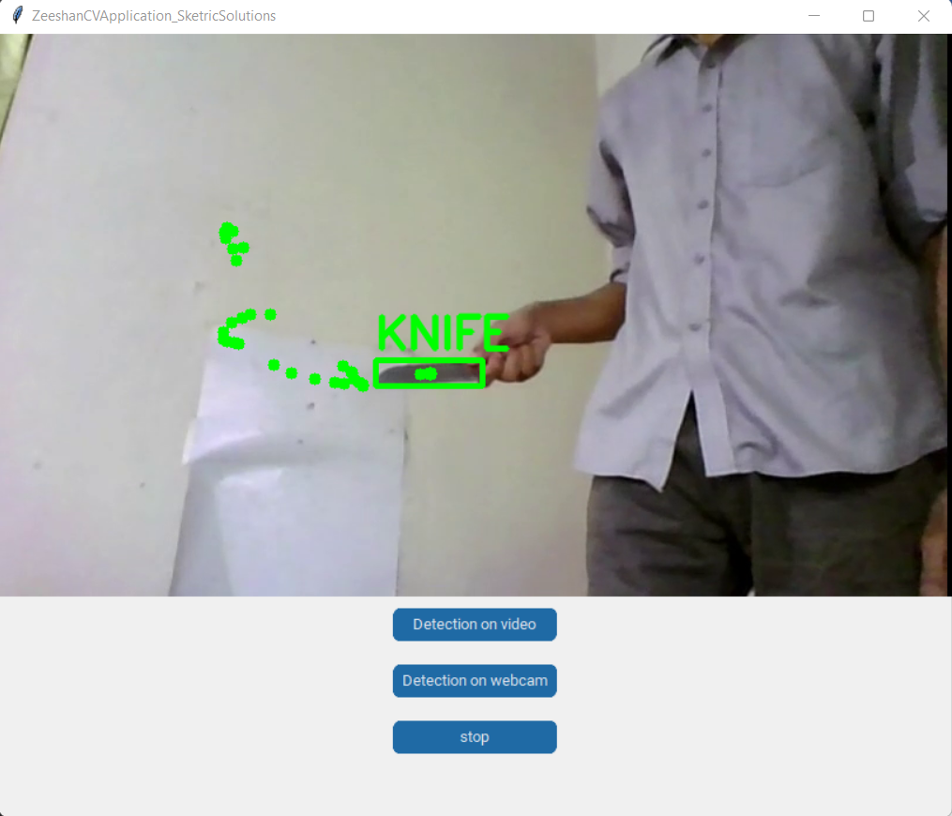

# How to run:

In order to run this code, several libraries need to be pre-installed on your system. It is recommended that you run following commands:

Pip install numpy

Pip install tkinter

Pip install customtkinter

pip install opencv-python

pip install ultralytics

pip install Pillow

Once all these are installed, navigate to the current directory from your python console and type

python application.py